**Cedarwood Alternative**

**Elementary School**

**Student & Family Handbook**

2024-2025

**Handbook Table of Contents**

Cedarwood Vision, Mission, and Goals 3

Positive Behavioral Intervention and Support (PBIS) 4-5

Project Adventure 6-7

Restorative Practices 8

HB 410 Overview/Parents’ Right to Know 9

Cedarwood Elementary School Parent 10

Involvement Policy

Appendix 1: Project Adventure 11

Appendix 2: Project Adventure Values Chart 12

**Cedarwood Vision, Mission and Goals**

Cedarwood’s school wide focus is to successfully implement the experiential learning cycle. “In its simplest form, experiential learning means learning from experience or learning by doing. Experiential education first immerses learners in an experience and then encourages reflection about the experience to develop new skills, new attitudes, or new ways of thinking.” Lewis, L.H. & Williams, C.J. (1994). In Jackson, L. & Caffarella, R.S. (Eds.). *Experiential Learning: A New Approach* (pp. 5-16). San Francisco: Jossey-Bass.

Experiential learning can be applied fully online, through a combination of synchronous tools such as web conferencing, asynchronous tools such as discussion forums and/or social media for group work.

[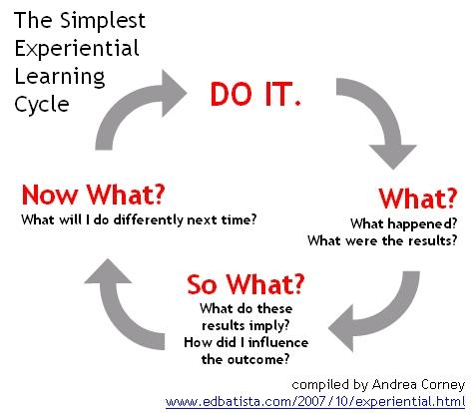](http://squareone-learning.com/blog/category/adult-learning/)

***What is Positive Behavioral Intervention and Supports (PBIS)?***

PBIS is a process for creating safer and more effective schools. It is a systems based approach to enhancing the capacity of schools to educate all children by developing research-based, school-wide, and classroom behavior support systems. The process focuses on improving a school’s ability to teach and support positive behavior for all students. Rather than a prescribed program, PBIS provides systems for schools to design, implement, and evaluate effective school-wide, classroom, non-classroom, and student specific plans. PBIS includes school-wide procedures and processes intended for all students and all staff in all settings. It is an approach to creating a safe and productive learning environment where teachers can teach and all students can learn. To learn more about PBIS, visit PBIS.org and/or watch this short video:

<https://www.pbis.org/video/a-pbis-success-story-featuring-the-rocklin-unified-school-district>

***What is PBIS at our school?***

At Cedarwood, we are committed to a Full Value Contract where Trust, Communication Cooperation, Challenge, Problem-Solving, and Risk are taught, practiced and applied.

**The 3 BEs…**

Rule #1: Be respectful

Rule #2: Be responsible

Rule #3: Be safe

At Cedarwood, students are taking on the *Project Adventure Pride* challenge. All students are asked to give a smile, hold the door, help someone in need, solve a problem, explain their thinking, take on a challenge, cooperate - small acts that show our best selves. Students who show positive leadership will be recognized and rewarded. There will also be various monthly celebrations for students who earn the right to participate (more information to come). These celebrations include, but are not limited to: an ice cream sundae party, a movie with popcorn, an extra recess, etc! Encourage your child to show Project Adventure Pride every day.

PBIS MATRIX

|  | **All Settings** | **Hallways** | **Cafeteria** | **Bathrooms** | **Playground** | **Assemblies** |
| --- | --- | --- | --- | --- | --- | --- |
| ***Be Safe*** | Keep bodies calm in line  Report any problems  Ask permission to leave any setting | -Walk  -Stay to the right on stairs  -Banisters are for hands | -Walk  -Push in chairs  -Place trash in trash can | -Wash hands with soap and water  -Keep water in the sink  -One person per stall | -Use equipment for intended purpose  -Wood chips are for the ground  -Participate in school approved games only  -Stay in approved areas  -Keep hands and feet to self | -Walk  -Enter and exit gym in an orderly manner |
| ***Be Respectful*** | Treat others the way you want to be treated  Be an active listener  Follow adult direction(s)  Use polite language  Help keep the school orderly | -Walk quietly so others can continue learning | -Eat only your food  -Use a peaceful voice | -Allow for privacy of others  -Clean up after self | -Line up at first signal  -Invite others who want to join in  -Enter and exit building peacefully  -Share materials  -Use polite language | -Be an active listener  -Applaud appropriately to show appreciation |
| ***Be Responsible*** | Be an active participant  Give full effort  Be a team player  Do your job | -Return to class promptly | -Use proper manners  -Leave when adult excuses you | -Follow bathroom procedures  -Return to class promptly | -Be a problem solver  -Learn new games and activities | -Raise your hand to share  -Keep comments and questions on topic |

***Project Adventure at Cedarwood Alternative***

Cedarwood is a Project Adventure school. We teach and promote life skills through Project Adventure activities each week for every student. These include trust, communication, cooperation, challenge, problem-solving and taking risks. Ask your students often about how they have developed trust, taken on a challenge, took an appropriate risk, cooperated with someone and used their problem-solving skills. By experiencing these in Project Adventure, our students can apply these skills in daily life. Remember: Strive for Growth, Be Honest, and Be Accepting! If you can’t solve a problem on your own, ask an adult for help! After all, life is an adventure! 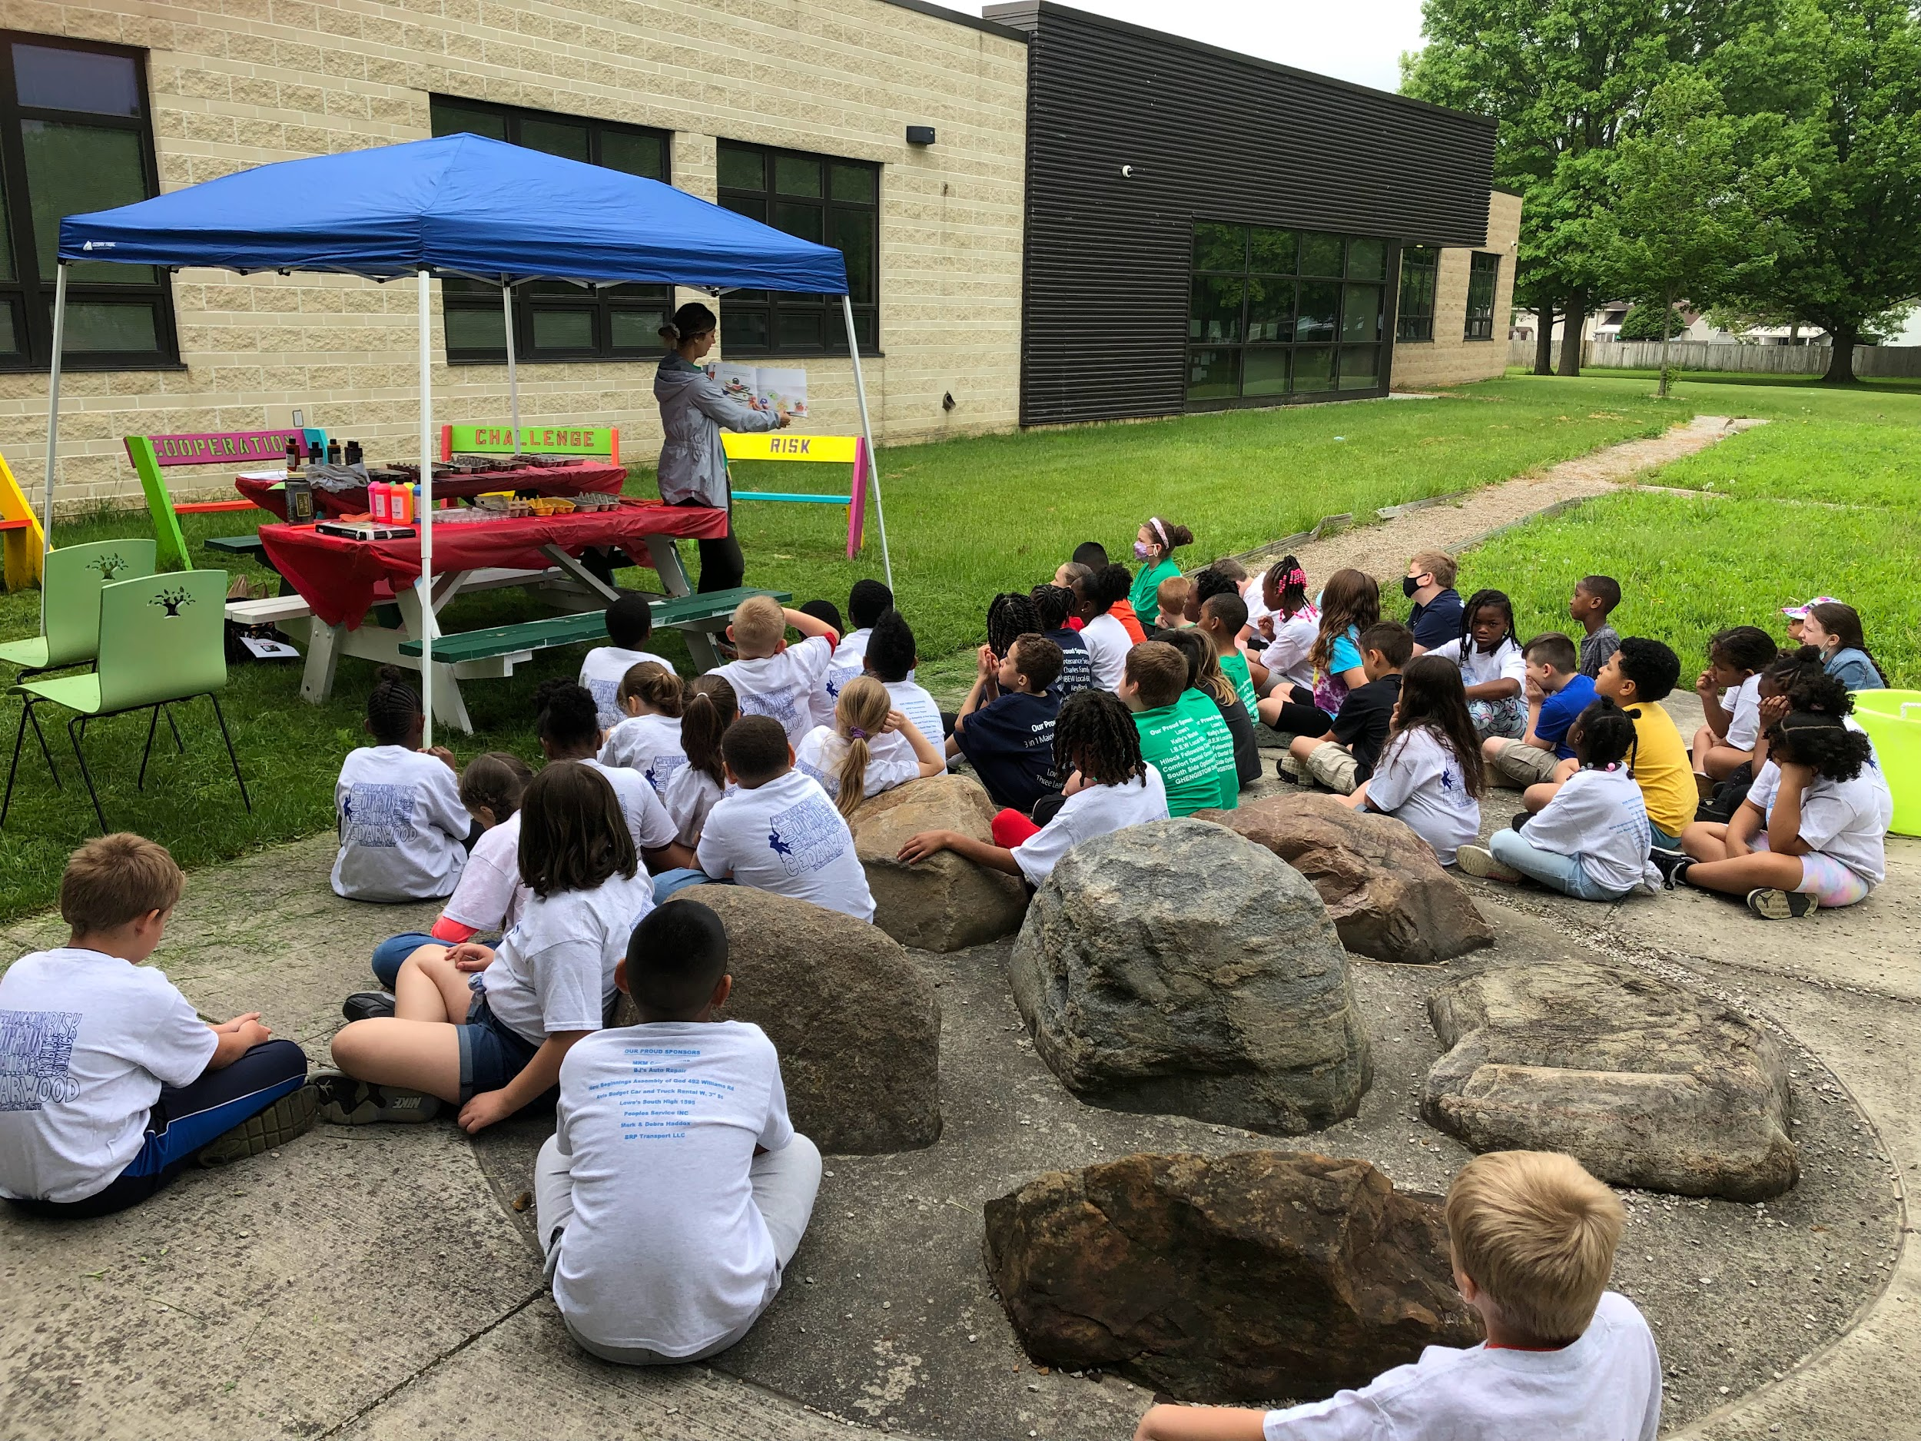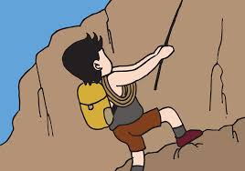

Project Adventure:

* Focuses on fostering learning and growth via adventure-based programming.
* The use of experiential and challenging approaches to education in new, unique and relevant activities to supplement conventional learning processes.
* Nurturing a healthy learning environment where students feel connected, safe and empowered.

Cedarwood is an alternative school. Our Project Adventure mission is what makes us special. In order to keep our mission strong, Cedarwood is required to collect fees from students. These fees assist with maintaining our Project Adventure mission. The fees cover the following expenses:

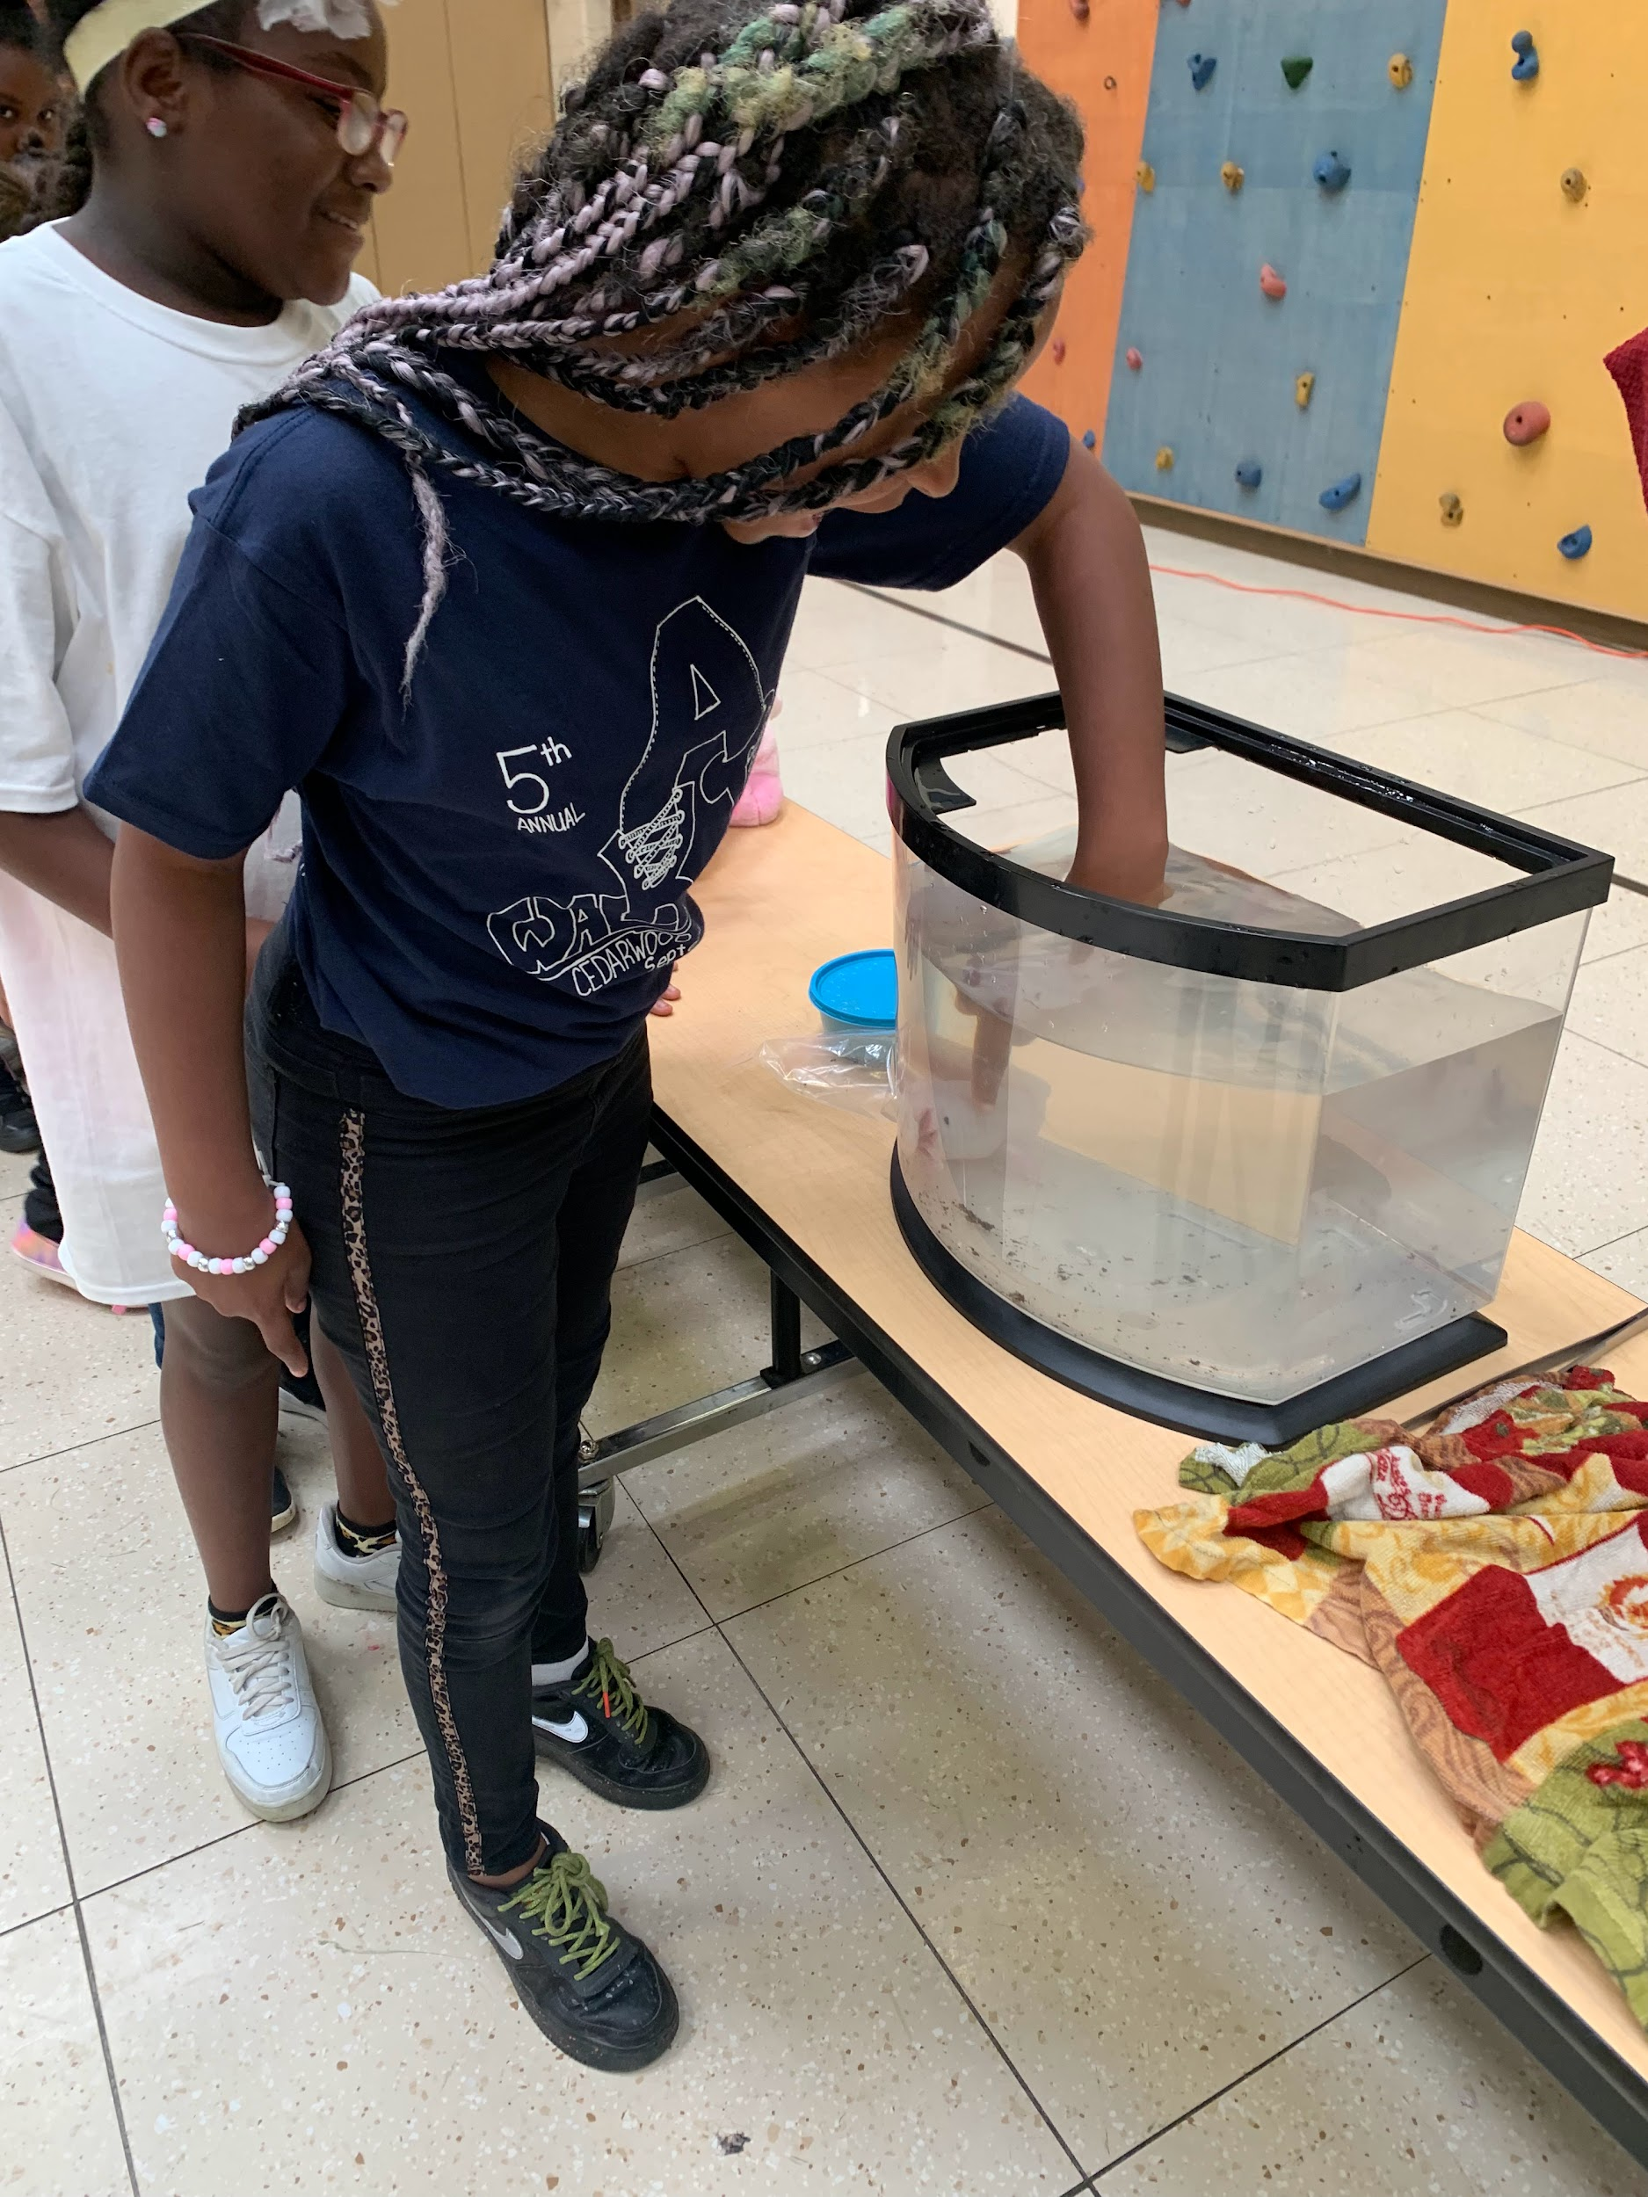

* Project Adventure designed field trips (ex. Metro Parks, Zip Zone)

* Yearly inspections to our FABULOUS gym with a climbing wall and zipline ($1000 +)

* Repairs for mechanical and wall pieces and climbing ropes when needed ($1100 + for one rope!)

* Additional classes each week for Project Adventure with materials provided

* Professional Development for staff and materials for Project Adventure in the classroom

In addition to kindly paying your fees by the due date, families can assist with our mission. Please consider signing up to volunteer during our Project Adventure Climbing Unit, which occurs twice a school year, or to chaperone field trips and attend camp with us!

**Note:** We also have a monthly Project Adventurer of the Month, which is an award for students who are recognized by staff for going above and beyond to demonstrate our school’s Core Values!

**Cedarwood Alternative Project Adventure**

**Procedures and Expectations**

| **Trust** |  | **Be Respectful**  **Be Responsible**  **Be Safe** |
| --- | --- | --- |
| **Communication** |  |
| **Cooperation** |  |
| **Challenge** |  |
| **Problem-solving** |  |
| **Risk** |  |

***Restorative Practices***

At Cedarwood, we use **Restorative Practices** to address social-emotional issues, including bullying. Restorative practices include steps taken to resolve conflict and prevent harm. These practices enable those who have been harmed to convey the impact of the harm to those responsible, and for those responsible to acknowledge this impact and take steps to put it right. The staff at Cedarwood have been trained and will continue to receive additional training throughout the year. Over the course of the year, they will implement strategies such as morning meetings and circle time, restorative conferences between individuals, and mindfulness techniques to create safe and peaceful spaces in the classroom and throughout our building. This brief video will provide some insight into Restorative Practices: 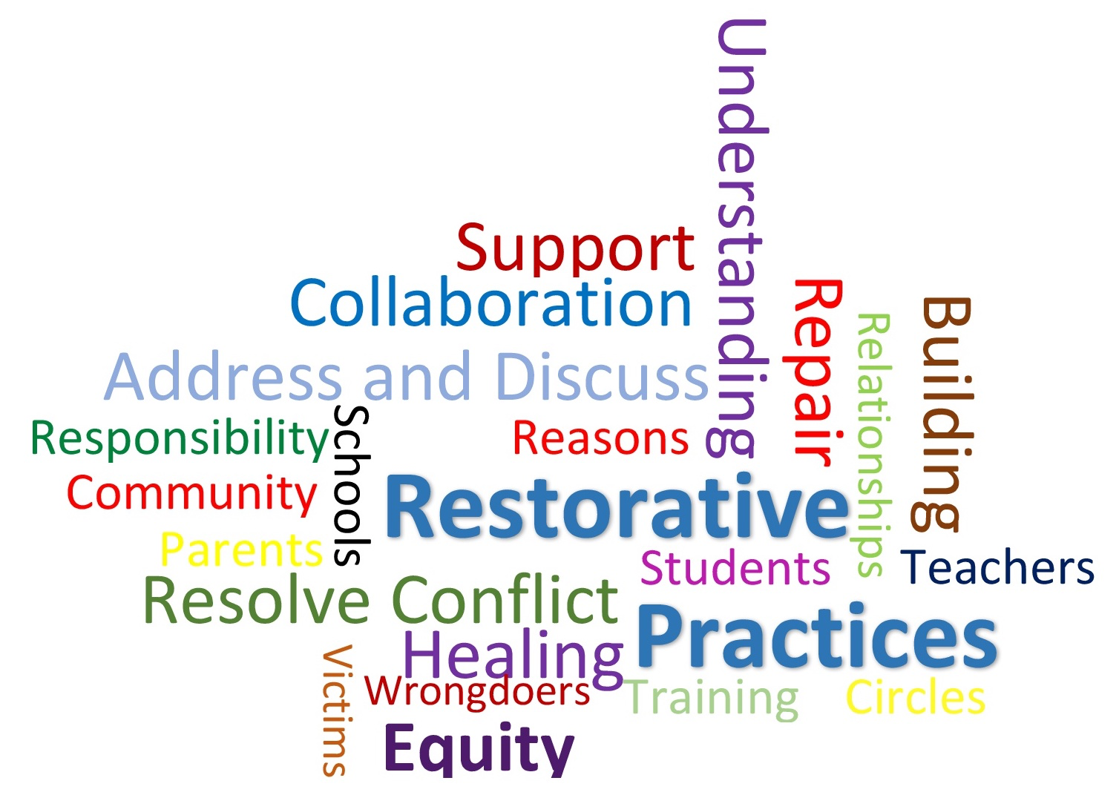

<https://www.youtube.com/watch?v=Kf22JzXbXEI>

Please contact your child’s teacher or our school counselor with questions about these or other programs. We teach our students, if you SEE SOMETHING, SAY SOMETHING! It takes all of us working together to create a safe and welcoming school environment for our students.

**Attendance is important to your child’s learning!**

Help your child get to school on time, every day. House Bill 410 has put school attendance policies into Ohio law. Absences are calculated by the number of minutes a child is absent from school. If your child is late to school each day, those minutes add up and count toward the number of days absent in a year. Please visit our website under Families for additional information on the attendance laws in Ohio. If a student is absent, please send a note to school (parent excuse or doctor’s note) on the day they return.

**Parents Right to Know**

Cedarwood Elementary is a Title I school. Parents may request information regarding the professional qualifications of their child’s classroom teachers, including the following:

• Whether the teacher has met State qualification and licensing criteria for the grade levels and subject areas taught;

• Whether the teacher is teaching under emergency or provisional status through which State qualifications or licensing criteria are waived;

• Whether the teacher is teaching in the field of discipline of the certification or degree; and

• Whether the student is provided services by paraprofessionals and, if so, their qualifications.

In addition, parents may request:

• information on the level of achievement and academic growth of their child on each of the state academic assessments required; and

• timely notice that the student has been assigned or has been taught for 4 or more consecutive weeks by a teacher who does not meet applicable State certifications or licensure requirements as the grade level and subject area in which the teacher has been assigned.

**Cedarwood Elementary School Parent Involvement Policy**

Cedarwood Elementary will involve parents in regular and meaningful communication addressing student achievement and ensuring:

* That parents play an important role in assisting their student’s educational success
* That parents are encouraged to be actively involved in their student’s education
* That parents are full partners in their student’s education and are included in school decision-making and on advisory committees to assist in the education of their student

Cedarwood Elementary agrees to implement requirements to:

* Involve parents in the planning and development of effective parent involvement activities through representation on school site based committees
* Build both the school and family capacity for parent involvement by:

* Providing parents with information on state standards, assessments, requirements of Title I, monitoring student progress and working with educators. Information will be provided during annual meetings, including parent teacher conferences, newsletters, on our school website and information throughout the school year.

* Providing materials and resources to help parents work with their student to improve academic achievement. Resources will be provided in school/classroom newsletters, through teacher communications and curriculum-related events.

* Communicating regularly with parents in clear and understandable terms. This will include opportunities for parents to participate in decision making roles, volunteer opportunities, Title I meetings, newsletters, conferences and surveys. Parent teacher meetings can be scheduled at any time as requested by parents and with the availability of staff members.

**Project Adventure Themes and Focus**

| **Project Adventure Theme** | **Week 1 Skill** | **Week 2 Skill** | **Week 3 Skill** | **Week 4 Skill** |
| --- | --- | --- | --- | --- |
| Trust | Welcoming | Being Safe | Being Respectful | Being Responsible |
| Communication | Listening | Focusing Attention | Using Self Talk | Being Assertive |
| Cooperation | Empathy | Identifying Feelings | Same and Different Feelings | Showing Compassion |
| Challenge | Feelings in My Body | Stop and Name Feelings | Calming Down | Managing Learning Challenges |
| Problem Solving | Say the Problem | Think of Solutions | Explore the Consequences | Pick the Best Solution |
| Risk | Inviting to Play | Playing Fairly | Making Amends | Handling Name Calling |

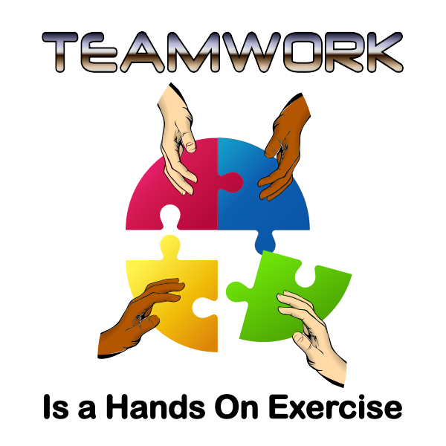

Project Adventure Values

| **PA Values** |  | **The Chromebook** | **In Google Classroom** | **In any virtual meetings** | **When using email** |
| --- | --- | --- | --- | --- | --- |
| **Trust**  **Communication** | I am **Ready** by… | Setting up my Chromebook and school supplies in my house.  Setting up a time to use the Chromebook every day. | Choosing a distraction-free space to work  Having all my supplies by me that I need (pencil, paper, Chromebook, headphones, charger, etc.) | Choosing a distraction-free space to work  Having all my supplies by me that I need (pencil, paper, Chromebook, headphones, charger, etc.) | Choosing a distraction-free space to work  Having all my supplies by me that I need (pencil, paper, Chromebook, headphones, charger, etc.) |
| **Cooperation** | I am **Respectful** by… | Taking care of my Chromebook.  Sharing the Chromebook with my brothers and sisters so that they can complete their school work. | Responding appropriately to assignments and questions that are asked.  No posting or having side conversations.  No inappropriate chatting. | Responding to subject-matter posts, only.  Using kind words.  Staying on task.  Having the video on at all times.  Listening to the teacher.  Letting 1 person talk at a time.  No inappropriate chatting. | Using kind words. |
| **Challenge**  **Problem-**  **Solving** | I am **Responsible** by… | Keeping drinks and liquids away from my Chromebook.  Keeping Chromebook charged.  Inform an adult if something is not working on the Chromebook. | Turning in work on time.  Trying my best to complete my work.  Responding to questions that the teacher posts. | Being on time to the meeting.  Participating in the discussions.  Paying attention. | Only using email for school-related information. |
| **Risk** | I am **Safe** by… | Finding a safe spot in my house to store my Chromebook when no one is using it. | Using the technology correctly.  Using only school- appropriate websites.  Keeping my login information private | Keeping my meeting times between my classmates and teacher, only.  Keeping my information safe. | Contacting and responding to emails from people I know. |

**“Together We Can Make A Difference!!”**